PICTURES FOR WEBPAGE – WHAT IS POSSIBLE TO MAKE
ATT: Madhur.
PACKSHOTS:
Reference: www.sophiebillebrahe.com

PLACEMENT:
Photo direct on the product and same view on all jewellery – it has to be same uniform when you see 30 pictures side by side.
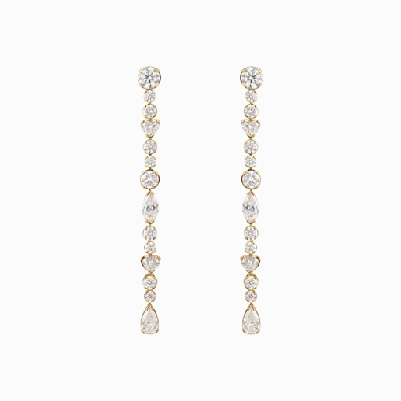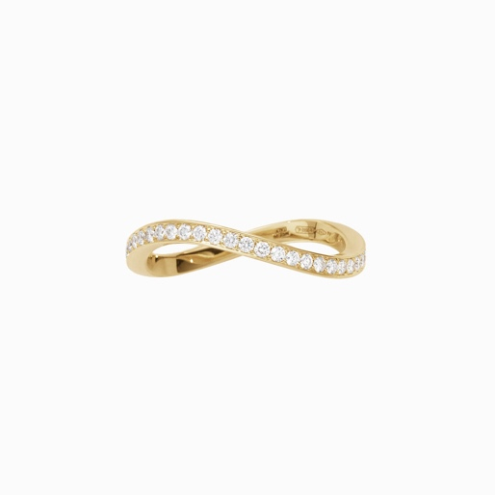
Version of one product – 3 images.
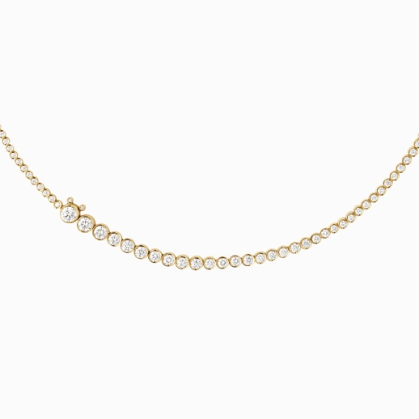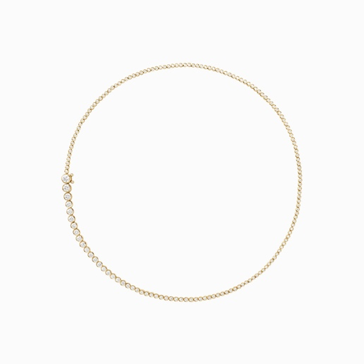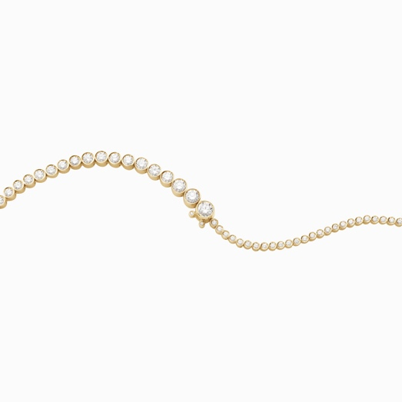
The colors of the stones and gold must appear accurate and natural.
Background:
- One version with a white background.
- One version with a colored background (for example burgundy, soft rose, or a similar tone).
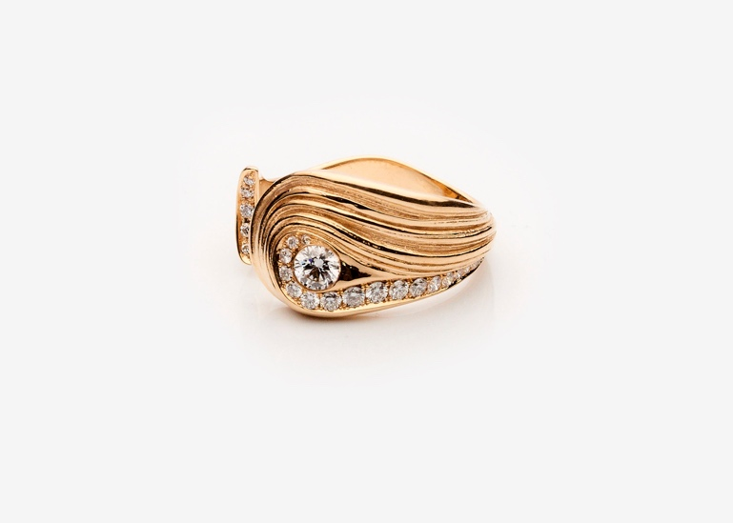
360 video:
I’m also interested in a 360° product video similar to this example:
https://akvajewellery.com/da/shop/consilium-da/ora-open-ring/

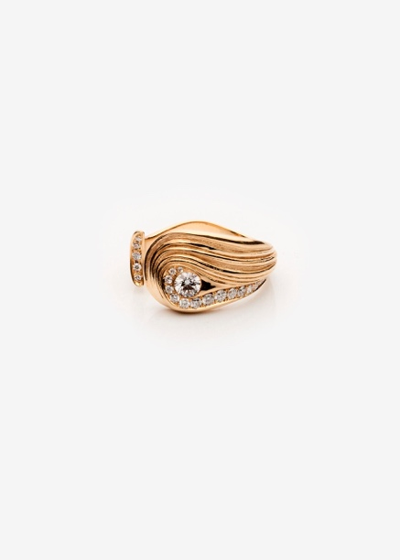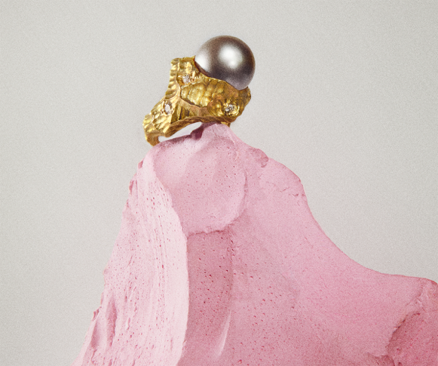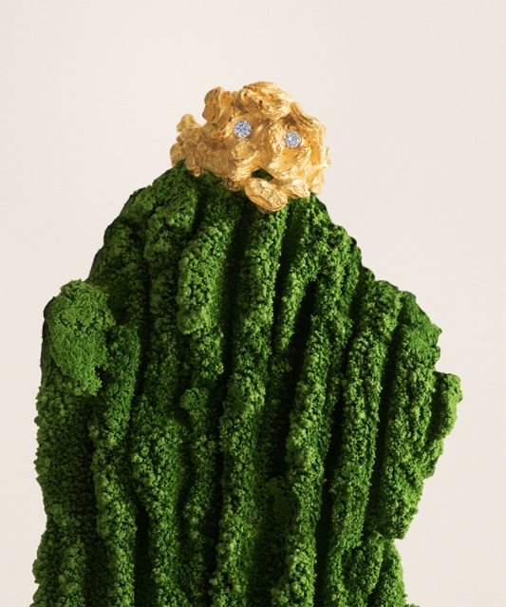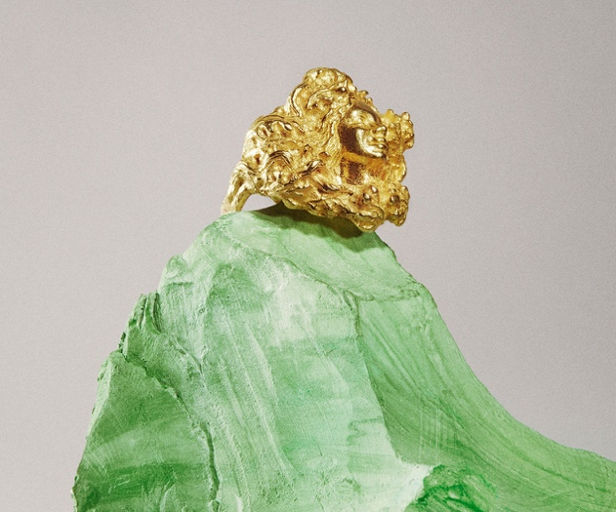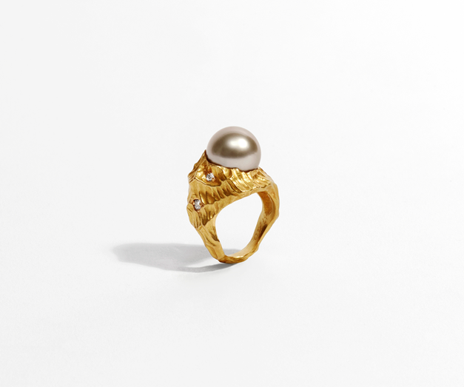

AI MODEL PICTURES:
Attached are examples of images I like. Would it be possible to create model pictures with the jewellery using AI?
The lighting and overall look in these references is the style I am aiming for.
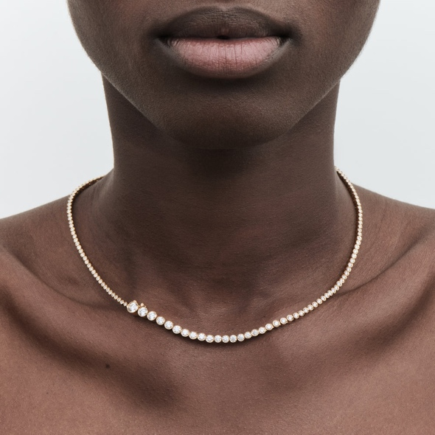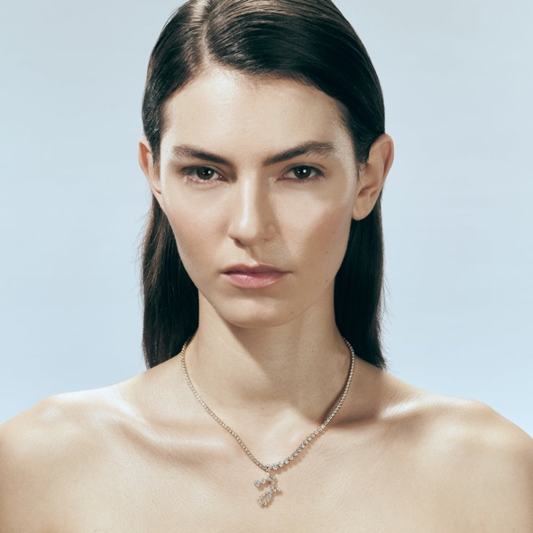

HAND PICTURES – REFERENCE
Reference: www.akva.com
Reference: www.sophiebillebrahe.com
Would it be possible to create similar hand images using AI?
What material or information would you need from us to make this possible?
I especially like the colors and the hand positions in the reference images.
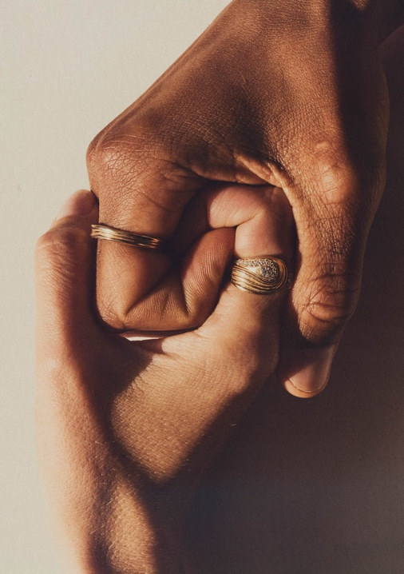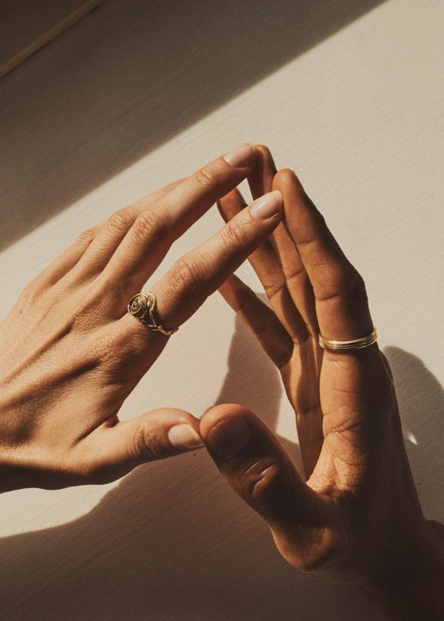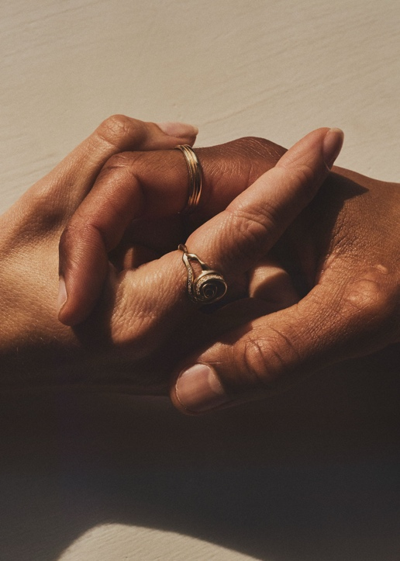
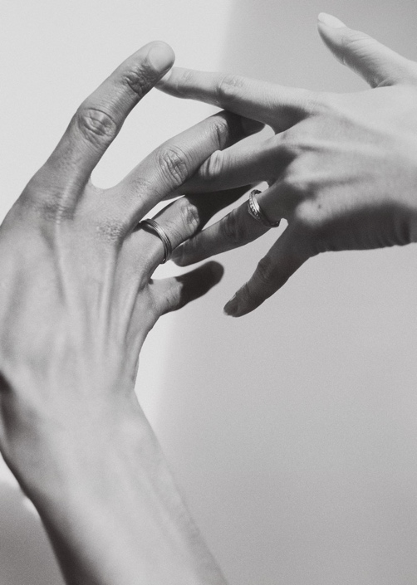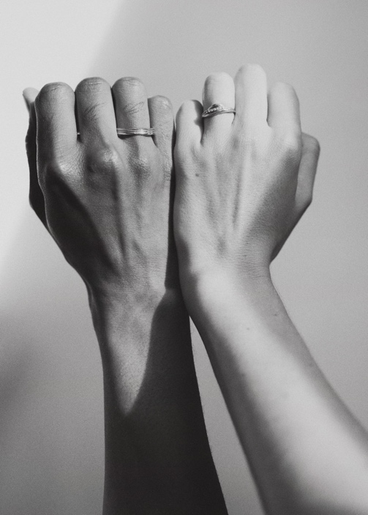
Ref: www.akva.com

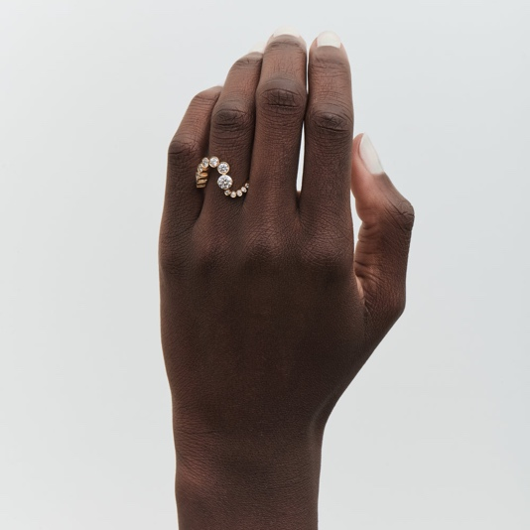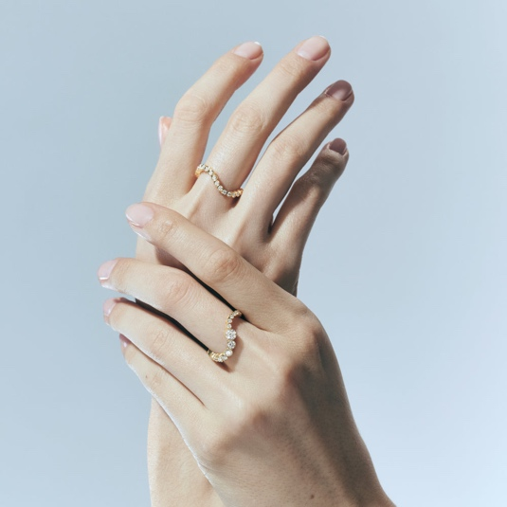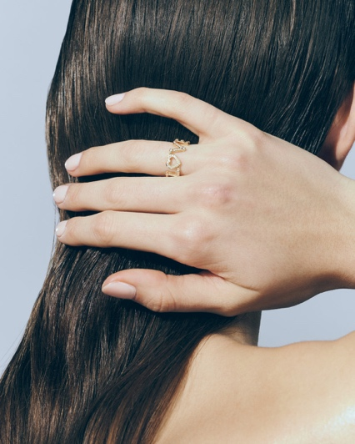
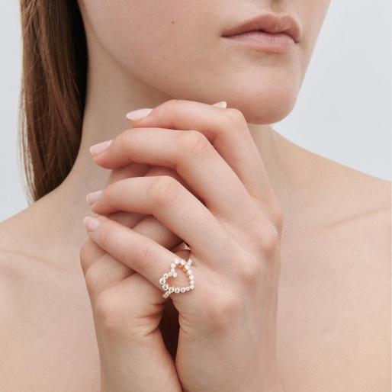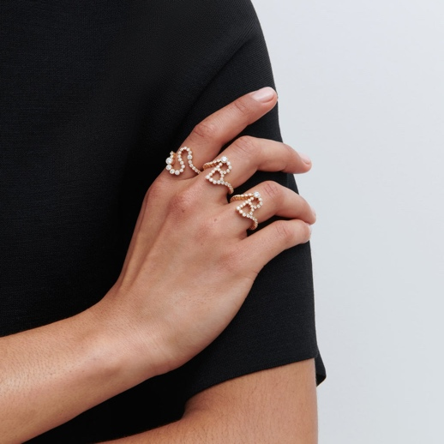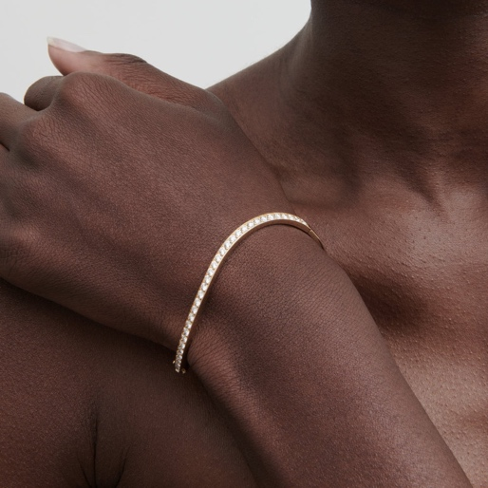
Ref.: www.sophiebillebrahe.com

